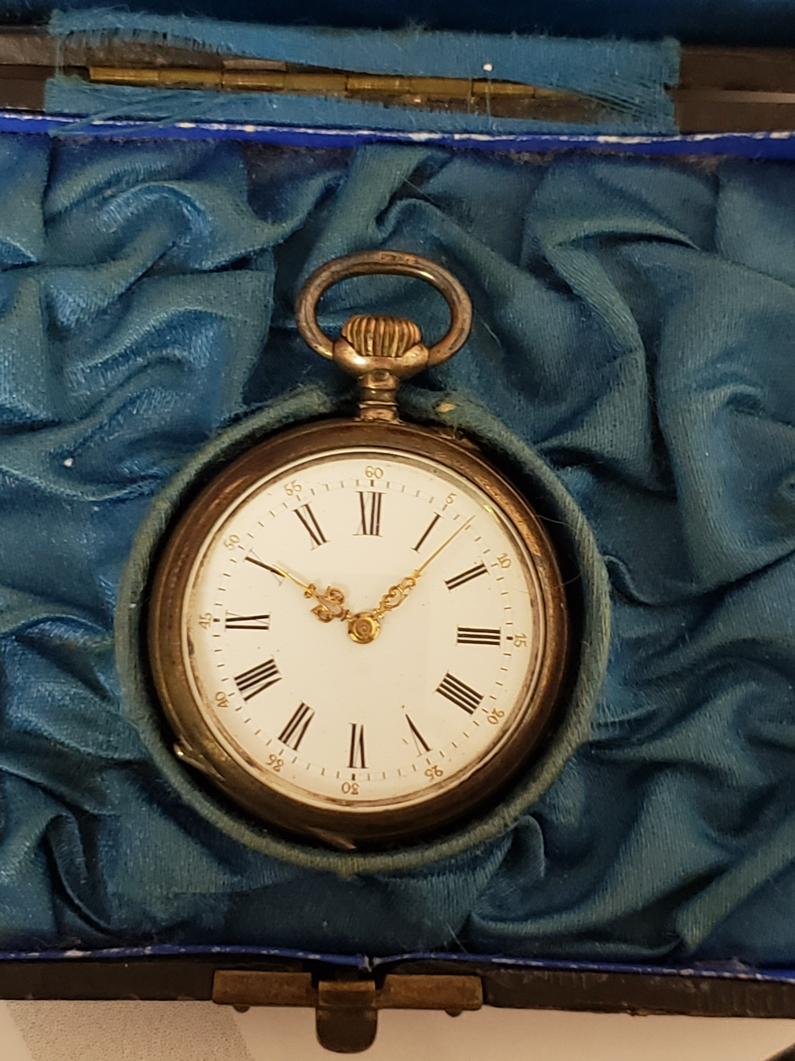

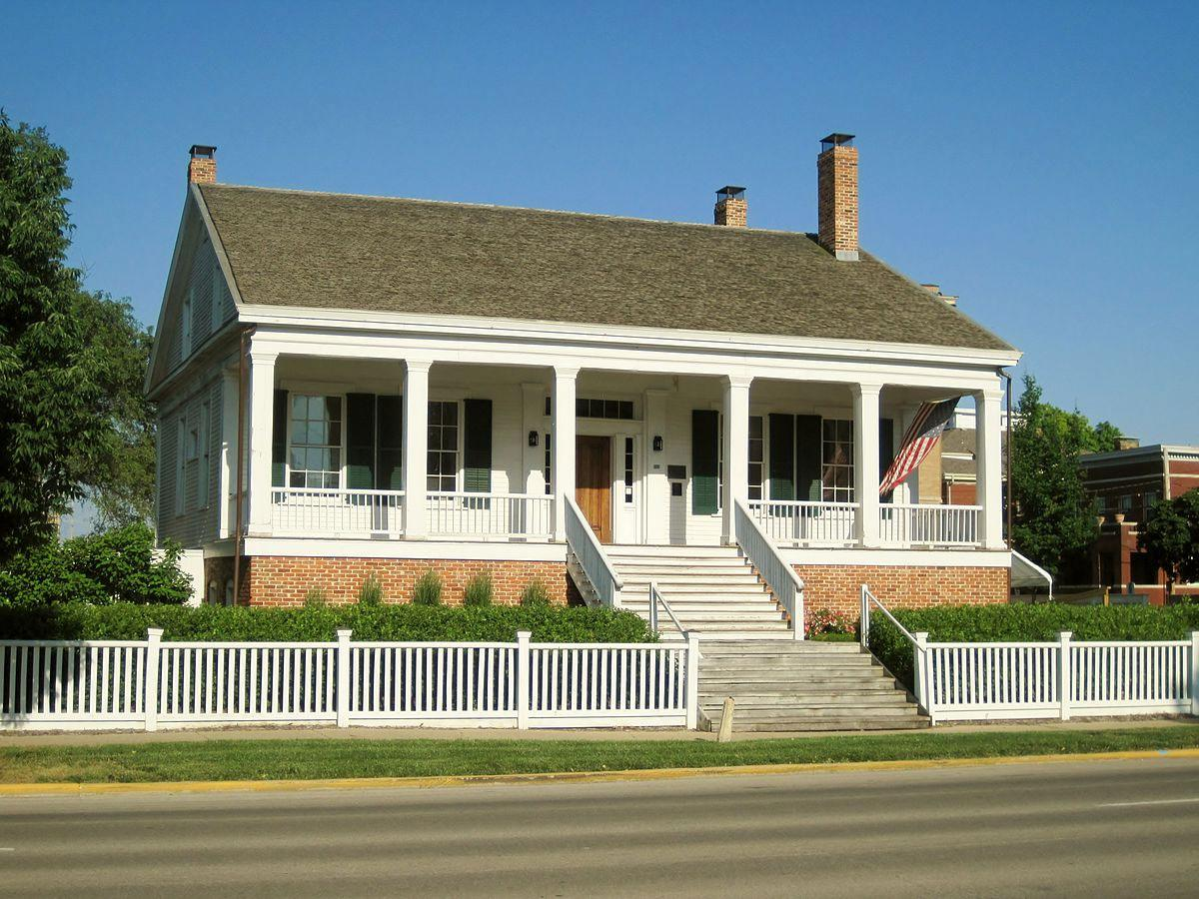
MOMCC
2021 Spring Conference
Call for Sessions and Speakers
Hosted by Elijah Iles House, Springfield IL
March 18-20, 2021

It’s About Time:
Looking at what we have done, are doing, and where we might go

Over the years, we have changed how we have connected history with visitors to help understand and learn from the past. Join us as we review how we have previously made these connections, how we are connecting today and how we can continue to meet the need of those visiting our historic sites.

The conference organizers seek speakers, session and workshop proposals relevant to this broad theme. Session topics may include, but are not limited to:

- Dealing with controversial issues, topics and needs
- Interpretation and audience changes, challenges and successes
- Programs – Past, Present and Future
- Staffing and volunteer issues
- Understanding funding sources
- Institutional tradition/cultural changes
- Working with schools and students
- Working with boards, administrations, staff and community
- Marketing in a changing digital world
- STEM/STEAM programming
- Historic crafts, trades and classes
- Managing collections
- Disaster planning and preparedness

Session proposals should be submitted not later than Sept 15, 2020
Submit to Tracie Evans, Program Chair, PO Box 235, Archbold OH 43502
tracie.evans@saudervillage.org Phone (419)446-2541 x2072 Fax (419)445-5251

Call for Workshops, Sessions, Panels, and Presentations

The Midwest Open Air Museums Coordinating Council seeks proposals for workshops, sessions, and presentations for the 2021 Spring Conference in Springfield IL. Half and full day workshops will be held March 18, and sessions on March 19-20. To submit a proposal, please ﬁll out this form attaching additional pages, if necessary. (E-mail is the preferred submission method.) All presenters must register for the full conference or for the day upon which they present.

Proposal Deadline: Sept 15, 2020

Title of Session:

Description: (overview of content, goals, application)

Format (mark one):
__ Presentation __ Panel/Roundtable Discussion __ Performance/Demonstration
__ Thursday Workshop __ Other (please explain) ___________________________

Length: __ 75 min session ___ 150 Min. double session __ 3 hour workshop __ 6 hour workshop

Workshops Only
Cost Per Person ________ minimum /maximum participants: _____
Indoor or Outdoor: ____________________ Space Size needed__________________________
A/V Needs: ________________ Will You Be Using a PowerPoint? Y __ N __
Special/ Additional Needs:

Session Leader Name and Position:
Afﬁliation:
Address:
Email Address:
Phone :

Additional Participants: (please provide same information as session leader for each additional participant, attach additional sheets as needed): ____________________________________

Contact a Board member or the planning committee if you need assistance in finding suitable presenters.

SUBMIT TO:
Tracie Evans, Program Chair
Sauder Village, PO Box 235 Archbold OH 43502
Tracie.evans@saudervillage.org
(419) 446-2541 x 2072

